Glade Primary School

RSE Policy 2019

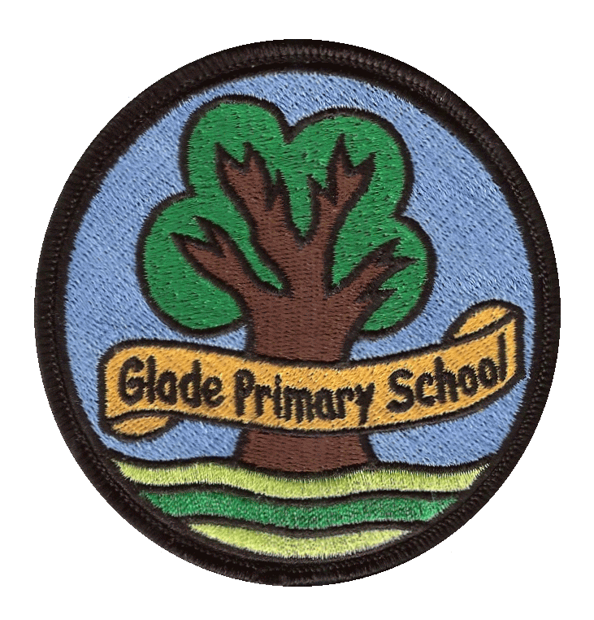

Growing, Learning & Achieving with Dedication & Enthusiasm
Addendum for Redbridge Schools RSE School Policies.

In accordance to the updated announcement shared by the DfE (June 2020) following the impact of Covid-19, Redbridge Schools will be extending the consultation and training period for the Revised RSE and Health Education Statutory Guidance September 2020.
Schools will continue to teach the current RSE curriculum in the academic year 2020/2021 unless otherwise stated by the school.
In Summer 2, 2021 schools will begin to teach some elements of the revised RSE curriculum. With the view to teach the full revised curriculum from September 2021.
By Summer 2, 2021 each school policy will have been revised and shared with families. The Local Authority and School’s consultation period regarding the revised changes to the curriculum will be complete.

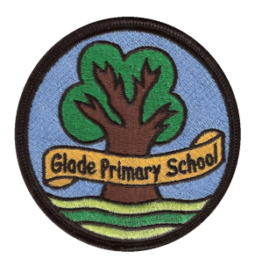

GLADE PRIMARY SCHOOL
RSE POLICY

School Statement
RSE is the lifelong learning about physical, moral and emotional development. Pupils are taught about the nature of family life of stable and loving relationships, respect, love and care.

As a rights respecting school, this policy supports the following articles from the UN Convention on the Rights of a Child:
Article 3: (best interests of the child) The best interests of the child must be a top priority in all actions concerning children.
Article 12: (respect for the views of the child) Every child has the right to say what they think in all matters affecting them, and to have their views taken seriously.
Article 19: States Parties shall take all appropriate legislative, administrative, social and educational measures to protect the child from all forms of physical or mental violence, injury or abuse, neglect or negligent treatment, maltreatment or exploitation, including sexual abuse, while in the care of parent(s), legal guardian(s) or any other person who has the care of the child. Such protective measures should, as appropriate, include effective procedures for the establishment
of social programmes to provide necessary support for the child and for those who have the care of the child, as well as for other forms of prevention and for identification, reporting, referral, investigation, treatment and follow-up of instances of child maltreatment described heretofore, and, as appropriate, for judicial involvement.
Article 28: (right to education) Every child has the right to an education. Primary education must be free. Discipline in schools must respect children’s dignity.
Article 29: (goals of education) Education must develop every child’s personality, talents and abilities to the full. It must encourage the child’s respect for human rights, as well as respect for their parents, their own and other cultures, and the environment.
Article 34: Children have the right to be free from sexual abuse.

Legal Requirements
This policy is intended to ensure that Glade Primary school conforms to the guidance for sex and relationships education as written in the national curriculum 2014.
Glade Primary School, like all schools, has this up to date RSE Policy, which is made available for inspection and to parents. The sex and relationships education is delivered through the science curriculum and through PSHE lessons. The governing body and head teacher determine the school policy that reflects the parents' wishes and the community they serve.

• It is compulsory for all maintained schools to teach some parts of sex education i.e. the biological aspects of puberty, reproduction and the spread of viruses. These topics are part of the National Curriculum Science which must be taught to all pupils of primary and secondary age.
• The broader topic of sex and relationships (RSE) is currently not compulsory but it is contained within non statutory PSHE education within the National Curriculum and is strongly recommended within Government RSE Guidance (2018). School governors are in law expected to ‘to make sure that‘ the school follows this guidance.

This states the following:

1.12 The Department recommends that all primary schools should have a sex and relationship education programme tailored to the age and the physical and emotional maturity of the children. It should ensure that both boys and girls know about puberty and how a baby is born – as set out in Key Stages 1 and 2 of the National Science Curriculum. Section 3 gives further information on what should be taught at these stages and how this should be rooted in the PSHE framework.
1.13 All children, including those who develop earlier than the average, need to know about puberty before they experience the onset of physical changes. In the early primary school years, education about relationships needs to focus on friendship, bullying and the building of self-esteem

Rationale behind the deliverance of a RSE Policy
An RSE Policy supports children as they grow and develop and in their academic achievement. Glade Primary School staff teach RSE to equip young people with the understanding, knowledge and skills to make informed, responsible decisions about different types of relationships, their own sexuality and sexual health.
This enables them to:
• Develop a sense of self-worth and well-being
- Understand that each person’s body belongs to them, and the differences between appropriate and inappropriate or unsafe physical, and other, contact
• Know the importance of respecting others, even when they are very different from them (for example, physically, in character, personality or backgrounds), or make different choices or have different preferences or beliefs.
- Be given opportunities to speak, have an opinion and be heard
- Feel valued and treated with respect
• Develop a greater understanding of the nature of relationships and the responsibilities of the individual
• Understand and have confidence in their ability to manage the changes that occur throughout puberty
- Develop confidence about achieving their goals
• Understand that the same principles apply to online relationships as to face-to face relationships, including the importance of respect for others, including the rules and principles for keeping safe online, how to recognise risks, harmful content and contact, and how to report them.

Links with other Legal Requirements
National Curriculum
The RSE Policy supports Aim 2 of the National Curriculum
2.1 Every state-funded school must offer a curriculum which is balanced and broadly based and which:
• promotes the spiritual, moral, cultural, mental and physical development of pupils at the school and of society, and
• prepares pupils at the school for the opportunities, responsibilities and experiences of later life.

The staff at Glade Primary School promote the development of pupils’ self-esteem and emotional well-being and help them form and maintain worthwhile and satisfying relationships, based on respect for themselves and others, at home, school, work and in the community. It develops their ability to relate to others and work for the common good.

Science in the National Curriculum
The law says that human reproduction must be taught as part of the content of the National Science Curriculum. At Glade Primary School, this is taught by teachers as part of the Science Curriculum.

PSHE in the National Curriculum
All maintained schools must meet the requirements set out in section 78 of the Education Act 2002 and promote the spiritual, moral, social and cultural (SMSC) development of their pupils. It is important that sex and relationships education be taught as part of PSHE education which develops essential skills and attributes, such as self-esteem, managing risk and resisting peer pressure which pupils can apply to a range of areas; and which addresses related factors such as alcohol and drugs, media literacy, and equality and prejudice. It is therefore recognised as best practice for RSE to be taught as part of a broader PSHE curriculum, to help pupils to develop the skills, knowledge and personal attributes they need to manage their lives and is endorsed by leading RSE bodies.

Relating RSE to the School Aims
At Glade Primary School the school aims are reflected in the RSE Curriculum.

Every child is given the opportunity to develop to the best possible standards through high expectations. A safe, happy caring community is guaranteed through the nurturing of the qualities of tolerance, racial harmony, respect and self-confidence.

While providing a broad balanced curriculum, the school enriches children’s lives in a positive social atmosphere. A secure foundation is provided on which personal and academic attainment can flourish. We ensure we have the best interests of the child at heart, respect children’s views and enable children to achieve their educational goals, when planning for provision of the SRE curriculum (See UN Convention on the Rights of a Child, Articles 3, 12, 19, 28, 29 and 34).

Emphasis is placed on a strong partnership between home and school, and the teaching of sex and relationships is sensitive to the range of values and beliefs within the school’s multi-faith and multicultural environment.

Content and Delivery
RSE is planned in each year group from Year 1, linking the content with PSHE and Citizenship, Science, Religious Education and English. Research has shown that good sex education helps to delay rather than to accelerate the age at which young people start to become sexually active. These findings support a programme of sex education that begins at Key Stage 1 and continues to build on previous learning. They indicate the need for sex education that is not just science but is also part of PSHE and Citizenship with the concept of ‘relationships’ at the heart of what is taught.

Class teachers teach the lessons in the classroom setting. They are given appropriate training to help them deliver lessons confidently. If a teacher feels uncomfortable about teaching an element of RSE, another teacher experienced in teaching RSE will take the lesson, or team-teach if that is felt appropriate. Whenever possible the school nurse is invited to give a talk. In addition, assemblies offer opportunities to reflect on RSE issues.
An outline of what is taught is as follows:

Year 1 | Name main body parts (including external reproductive organs) (link to Sci) / Changes since they were babies (link to Sci)/ What does family mean to us? (link to RE) /Being friends (link to PSHE) / People who can help us (link to PSHE) / Respect my body and understand which parts are private
Year 2 | Using correct names for body parts - similarities and differences – challenging stereotypes (link to PSHE and Sci)/ Animals, including humans produce young / How parents look after their young - animals, including humans (link to Sci) / Respect my body and understand which parts are private
Year 3 | Our personal interests and skills (link to RE). The lives of people living in other times – with different values or customs (link to history) / / Identify how boys’ and girls’ bodies change during the growing up process Friendship / Understand how babies grow and develop in the mother’s uterus
Year 4 | What makes a friend? / Who can help us? / Where can we find support? (link to PSHE) Support networks / Peer and media pressure (link to literacy and PSHE)/ Labelling external and internal parts of bodies
Year 5 | Male and female sex organs and womb (link to Sci and PSHE) / Puberty (link to life cycles in Sci)/ and preparing to cope with changes/ Personal hygiene – sweat increases as a teenager (link to Sci) Human reproduction (link to Sci), Development of a baby (link to Sci) Main stages of the human life cycle (link to Sci)
Year 6 | Changes in the human body puberty is reached (PSHE)/ Recognise and challenge stereotypes (PSHE) Know that there are some cultural practises which are against British law and universal human rights.

Techniques for Teaching RSE
Wherever RSE takes place, and whatever opportunities and approaches are chosen, it is essential that a secure learning environment is established.

Ground Rules
• No one will have to answer a personal question.
• No one will be forced to take part in a discussion.
• Only the correct names for body parts will be used.
• Meanings of words are explained in a sensible and factual way.

Distancing Techniques
Teachers avoid embarrassment and protect pupils' privacy by depersonalising discussions.

Dealing with Questions
Teachers establish clear parameters of what is appropriate and inappropriate in a whole class setting:
• If a question is too personal, the teacher reminds the pupil of the ground rules.
• If the teacher does not know an answer to a question, he/she suggests that this be researched later.
• If a question is too explicit or inappropriate for a whole class, the teacher acknowledges that it will be addressed later on an individual basis.
• In Year 5 or 6, a question box can be used where pupils can anonymously, if wished, place questions after a discussion or RSE session. The teacher can then answer and discuss these questions at an appropriate time with the class.
- In the event that a disclosure has been made, the school safeguarding policy must be adhered to.

Discussion and Project Learning
Pupils take part in a structured activity in which they can:
• Draw on previous knowledge
• Practise their social and personal skills
• Consider their beliefs and attitudes about different topics
• Reflect on their new learning
• Plan and shape future action

The government recommends that schools address LGBT (lesbian, gay, bisexual and transgender) issues and they are integral throughout the programmes of study. As with all RSE teaching, schools should ensure that their teaching is sensitive, age-appropriate and delivered with reference to the law.

Assessment of RSE Teaching
The PSHE and science leaders liaise with teachers in the different year groups as part of the school's monitoring policy. Teachers assess the lessons as part of the weekly and termly assessment policy and report important issues to the Headteacher and PSHE Leader.

Pupils reflect on their own learning to consolidate what they have learned to form new understanding, skills and attitudes. Circle Time is a useful tool to aid reflection.

Working with Parents
Glade Primary School staff work in partnership with parents and concerns can be discussed with the class teacher. They are consulted by letter and a meeting led by the school nurse on the content of sex and relationships education programmes. Although parents have the right to withdraw their children from all or part of the sex and relationships education, as stated in the prospectus; liaison with home and school ensures that this rarely occurs.

In this situation it may be appropriate to offer leaflets or details of organisations that can support them in talking to their child about sex and relationships.

The National Children’s Bureau (NCB) produces a number of factsheets designed to help adults speak about sex and relationships to their own children, to children in foster care and to looked-after children in public care. These are available from the Sex Education Forum (www.ncb.org.uk/sef/). In addition guidance for parents can be obtained from the NSPCC.

In the RSE Curriculum particular regard is given to SEN Pupils. They are given individual support to ensure understanding and avoid misconceptions. Ethnic and religious groups are also considered. Bilingual teachers and Learning Support Assistants can be called upon as required.

Confidentiality
Teachers cannot offer unconditional confidentiality. Teachers are not legally bound to inform parents of any disclosure unless the head teacher has specifically requested them to do so. In cases where there are child protection concerns, the teacher will ensure that the pupil understands that if confidentiality has to be broken, they will be informed first. Health professionals in school are bound by their codes of conduct in a one-to-one situation with an individual student, but in a classroom situation they must follow the school's child protection policy and the code of conduct for staff.

Using Visitors

The School Nurse and other Health Professionals work with teachers to jointly plan, deliver and evaluate sex and relationships education.
This policy will be implemented with reference to the Race Equality Policy, Health & Safety Policy and Every Child Matters.

Rights Respecting School
As an accredited Rights Respecting School, we are a community where children’s rights are learned, taught, practised, respected, protected and promoted. Through the Homework policy, pupils will develop a deeper understanding of the UN Convention on the rights of the Child, with particular reference to Articles 28 and 29.

Review

This policy will be reviewed as it is deemed appropriate, but no less frequently than every 2 years. The policy review will be undertaken by the Head teacher, or nominated representative.

Glade Primary School

